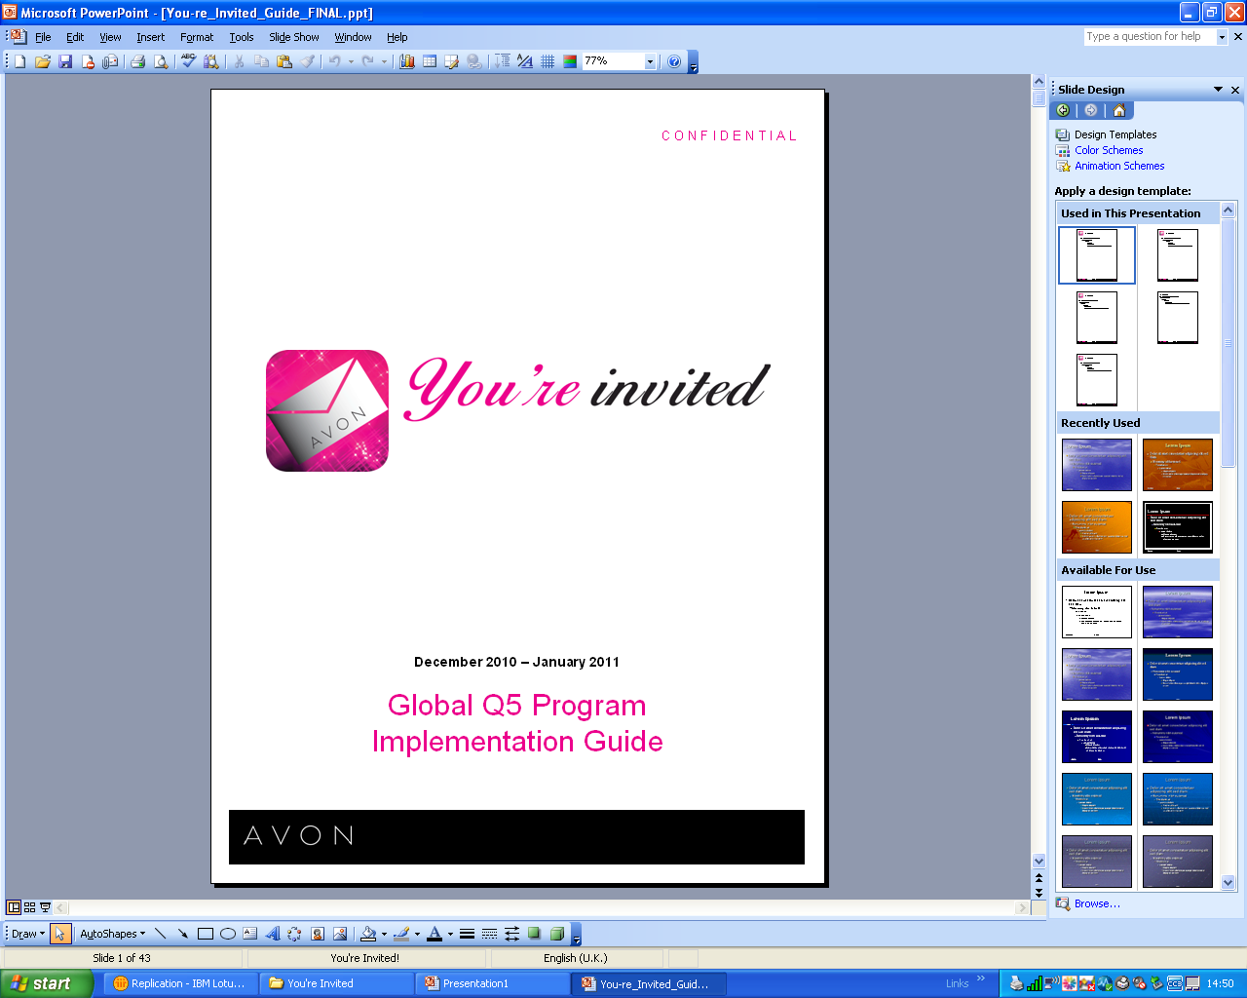

5th Quarter Support Guide

CONTENTS

Scripts to support all of your 5Q telecontact
- Inactives
- Order Management
- Recruitment
- Overcoming objections
- Sales Leader Development Call

Online Templates to gain momentum around ‘You’re Invited’
- Social Networking
- Email Contact

Script to support Inactive calls

Key points to include:
- Personalise to your style
- Ensure Representatives understand the importance of their customers seeing the brochure every campaign
- Highlight key selling points from the relevant brochure
- One Stop Selling method

Hello it’s xxxxxx

Just called to say hi and to give you some help with protecting your Avon earnings over the Christmas period.

You will see our brochures are packed full of fantastic offers not only for Christmas, but great money saving opportunities in the New Year too…

I notice that we didn’t receive an order last campaign, I hope everything is okay? What are your plans for this campaign,

(SL to discuss and overcome any selling challenges the Representative may have)

I just wanted to remind you that your Campaign XX Order is due on XXXX. How much have you sold for this campaign?

Caller’s Response | Your Reply
I haven’t sold anything yet | Don’t worry. You still have a week to go until the order is due. So you still have time to get your brochures delivered and collected.
I have a small order | Great! We still have a week to go before you need to submit the order. How many orders have you still to collect? What about your neighbours?  Have you seen a recent ‘Hello Tomorrow’? This is packed full of demonstration items that you can show your customers, encouraging sales for future campaigns. What products have you spotted that you like?

To help save you time, you may want to try one stop selling….

When you collect your Campaign 1 brochures leave a Campaign 2 brochure with everyone who has placed an order. When you deliver their Campaign 1 products you will be able to pick up their Campaign 2 order and therefore not have to go out between Christmas and New Year.

NB: The Representative could also leave a campaign 3 brochure to collect on the delivery of Campaign 2 order

Order Management Calls

PLEASE NOTE YOU MUST HAVE THE REPRESENTATIVES PERMISSION BEFORE PLACING AN ORDER ON THEIR BEHALF – WHERE POSSIBLE REFER THEM TO SELF SERVE VIA INTERNET OR FAST TRAK

Hello, it’s XXXX, I’m processing Campaign XX Orders and I notice yours is missing. How many customer orders did you have this campaign?

Caller’s Response | Your Reply
I haven’t got an order | Have you got brochures for XX Campaign?  Brochures are essential to ensure your customers don’t miss out,  Would you like me to order your brochures? How many packs would you like? The more brochures you order the cheaper they become and the more customers you can serve! The prices are as follows:  GO THROUGH THE PACK PRICES  Have you seen a current ‘Hello Tomorrow’ – What products have caught your eye? Ordering one of these will allow you to demonstrate to your customers encouraging sales for future campaigns. Would you like me to order it for you?
I have a small order | Would you like me to place them for you as the order is due in today?  The cut off is tomorrow at 10pm for online orders. Are you able to place them before this time, or would you like me to place your order on this occasion?

- Complete all requested actions. E.g. place the order
- Remind them of their delivery date and future order dates
- Thank them for their time

PLEASE NOTE
It is your sole responsibility to contact LOA 1 & 2
LOA 3+ may already have had an order management call, if this is the case please continue….

- “ That’s great, did you take advantage of our fabulous pack offer?”

- You can then continue with your call

Recruitment

Hi, can I speak to XXXX
My name is XXXX an Independent Sales Leader for Avon Cosmetics, a colleague of XXXX, She/he has recommended you to me as someone who may be interested in an earning opportunity.
I will be in your area on (date) and (alternative date), and I wondered when it would be a good time for me to call by and tell you all about it, under no obligation.

Cold Leads
Hi, can I speak to XXXX
My name is XXXX an Independent Sales Leader for Avon Cosmetics. I’m calling about a fantastic earning opportunity that we have available.
I will be in your area on (date) and (alternative date), and I wondered when would be a good time for me to call by and tell you all about it, under no obligation.

Caller’s Objections | Your Response
I haven’t got time, my children are still at school | I know how you feel. When I started Avon my daughter had just started school. It was great, because I found that I could work around the school hours, still be a mum and earn some extra money too.
I couldn’t knock on doors | I felt like that about knocking on doors, but I soon found it didn’t take me long to get used to it.  Within a few weeks, I found I had met most of the people on the estate and lots of them were really friendly.
No-one would buy Avon | Have you seen a brochure recently?  I’m sure that once you and your friends see our recent brochure they will be keen to buy from you.
I’ve just had a baby | Another Representative who is also a new mum felt like that. However, she soon found that she enjoyed taking the baby out with her – and the customers were very welcoming and made a fuss of her son.
I’ve just moved here and I don’t know anyone | I felt like that when I moved into my new house, but within a few weeks I found that I had met most of the people on the estate and they were really friendly!
My husband wouldn’t like me going out in the evenings | I could show you a way of covering this area without having to go out in the evenings, how would you feel about it then?  Suppose we could chat to your husband and explain what is involved, how would you feel about it then?

Sales Leadership Development Calls

Hello, this is XXXX, your Avon Independent Sales Leader.
I would like to book some time with you, to discuss your Avon business. How would you like to earn some more money?
Have you heard about our fantastic earning opportunity called Sales Leadership? I’m in your area on Tuesday morning, how about (time)?

Caller’s Objections | Your Response
I work full time and don’t get home until late | I could meet you for a coffee during your lunch break or do you have a day off, that would be suitable to get together?
I haven’t got time for Sales Leadership | Suppose I could show you how little time it takes? How would you feel about it then?  One of the great benefits of Sales Leadership is you choose your own hours and how much you put into it.
I have a baby and can’t afford a child minder | That’s the great thing about Sales Leadership – you can choose your own hours of work that suit your lifestyle, whilst earning extra money too!
I don’t know anyone who would sell Avon | That’s not a problem. I can help show you different ways to overcome that.
I’m not confident knocking on doors | I felt like that when I first had to knock on doors. However, I found that most people were really friendly.

Text you can use on Social Networking

Promoting your Pre Christmas planning meeting to your Downline Sales Leaders
  - My team loves what they do; don’t miss our success session on DATE/TIME
  - Want to earn more? I can help you plan. Don’t miss our team workshop DATE/TIME.
  - Need a get-away? Come to our meeting for conversation, fun, and a success plan.
  - Dreaming of perfect holiday gifts? Let’s figure out how to build your business so finances don’t get in the way!

Recruiting
  - Reinvent yourself this holiday season! One lipstick can change your look … and might just change your life!
  - Do you love meeting people? Want help paying your bills? Call me for a great earning opportunity.
  - For 125 years, Avon has provided earning opportunities… Find out how great it is to be a part of the world’s largest direct seller and a leading beauty company.
  - Who doesn’t love makeup? Now, you can make money, meet new friends, and have fun - all from the power of lipstick! Call me for information.
  - This year Avon is 125 years strong! Great products …. Fantastic brand recognition … And a whole lot of fun! Let me give you more details.
  - You are invited! Avon turns 125 in 2011, and I want to invite you to shop, earn, enjoy!
  - I love what I do…. So can you! Shop. Socialise. Earn. Find out how.

Text you can use on Email to Sales Leaders to promote 4th Jan ‘You’re Invited’ day

Prospecting

Dear

I would like to invite you to a fun day of meeting new people and growing your business. With a chance to achieve the “You’re Invited” incentive, this is a great time to go out prospecting.

Bring along your Prospecting cards. They are great to give to interested individuals. I will be holding group prospecting events on the following dates and times:

{Add prospecting dates and times}

I can’t wait to see you!

