
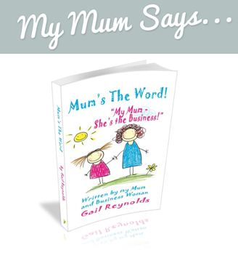

Venue
The County Arms
Highertown
Truro
Cornwall
TR1 3PY
Date
Tuesday 11th October
Time
9.30am - 12pm
When you arrive you can expect to see
- Recognition *Incentives *Free Gifts *Raffles *Future Events
- A Motivational & Moving experience with Gail Reynolds. Sharing her story and her Systems to Success
- Book signing on the day, Mum’s The Word is £10.00 Written by Gail Reynolds is packed with honest and thought provoking ideas to help you build your business & get immediate results
- Q & A Section for you to ask Gail whatever it is your business needs to boom for this winter
When you leave you can expect to have
- Training & Motivation * Team work & Team Spirit *Top Tips and Ideas to build your Avon Business
A Motivational Meeting with Guest Speaker
Gail Reynolds

